# Project 1: Create an Order application

**Purpose:** For Project 1, you’ll create an application that allows the user to place an order at a fictitious coffee shop named Conestoga Condors Coffee.

## Sample User interface

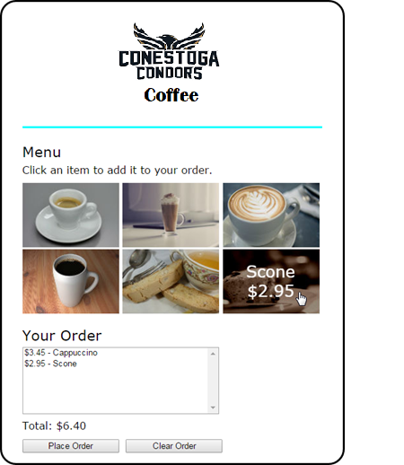

## Specifications

* When the user hovers the mouse over one of the images in the menu, another image should be displayed with the description and price of the item. The id attribute of each image identifies the image to be displayed when it’s rolled over.
* The rollover images should be preloaded.
* When the user clicks on an image, the order list and order total should be updated and displayed.
* If the user clicks the Place Order button, the checkout.html page should be displayed.
* If the user clicks the Clear Order button, all of the items should be removed from the order list and the total should be cleared.
* Add an ‘about’ page which states the company purpose.
* Add additional CSS styling
* Make the page responsive to Tablet and Handheld breakpoints.

## Other Considerations

## User interfaces

* You should think of the user interfaces that are shown as starting points. If you can improve on them, especially to make them more user-friendly, by all means do so.

## Specifications

* You should think of the specifications that are given as starting points. If you have the time to enhance the applications by improving on the starting specifications, by all means do so.

## Top-down development

* Always start by developing a working version of the application. That way, you’ll have something to show for your efforts if you run out of time. Then, you can build out that starting version of the application until it satisfies all of the specifications.

**Please refer to the Project 1 Rubric for a complete breakdown of the grading scheme.**